*Week* 4

**Design of Full adder**

Carry Propagate Adder (CPA)

* Full adder is an arithmetic logic unit or circuit to add two single digit numbers with Carry-in
* It is still combinational circuit with inputs Ax and Bx
  + Sx – Sum (1bit); C-in; Cx – Carry out;
* Adder is also called Ripple Carry Adder (RCA)
* Fundamental circuit for an adder and has longest propagation delay that is proportional to the number of the carry bits.
* Equation to estimate the propagation delay of an n-bit CPA. ∆FAC and ∆FAS stand for delta time for carry bit and delta time for sum signal propagation delay of a Full Adder (FA)

∆CPA(n) = [ (n-1) * ∆FAC ] + ∆FAS  Eq(2.8)

* Using AND/OR/EOR gate, ∆ for AND/OR gate is = 0.1 ns and ∆ for EOR = 0.3ns, ∆FAC = 0.2ns and ∆FAS = 0.3ns, as per Eq(2.8)
  + For 8 bit CPA (n=8), the equation to calculate propagation delay is as follows:

∆CPA(n) = (n -1)(0.2ns) + 0.3ns

= (8-1)_(0.2nx) + 0.3ns

***Block Diagram of Full adder***

Sx

Ax

Full Adder

Cx-out

C-in

Bx

**Design of Full Adder**

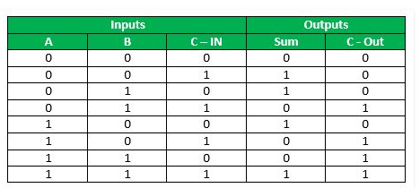

**Schematic of a 4 bit Cary Propagate Adder (CPA)**

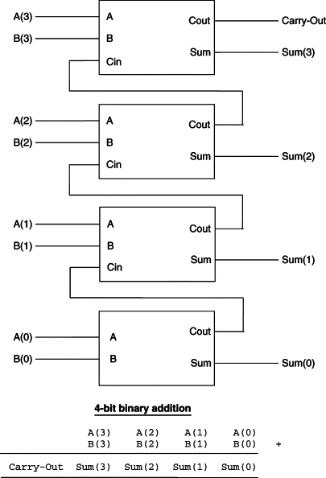

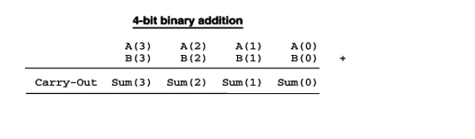

Binary Addition review:

|  |  |  |  |
| --- | --- | --- | --- |
| A | B | S | Cout |
| 0 | 0 | 0 | 0 |
| 0 | 1 | 1 | 0 |
| 1 | 0 | 1 | 0 |
| 1 | 1 | **0** | **1** |

12 + 12 = 102

110 + 1 = 210 = **10**2

12 + 12 + 12 = 112

9

+ 1 =

10

A = 0111

B = 1111

|  |  |  |  |  |
| --- | --- | --- | --- | --- |
| **Inputs** | | | **Output** | |
| A[i} | B[i} | C-in | S | C out |
| 1 | 1 | 0 | 0 | 1 |
| 1 | 1 | 1 | 1 | 1 |
| 1 | 1 | 1 | 1 | 1 |
| 0 | 1 | 1 | 0 | 1 |

**Design a full adder from ground up…. (Exercise video Note)**

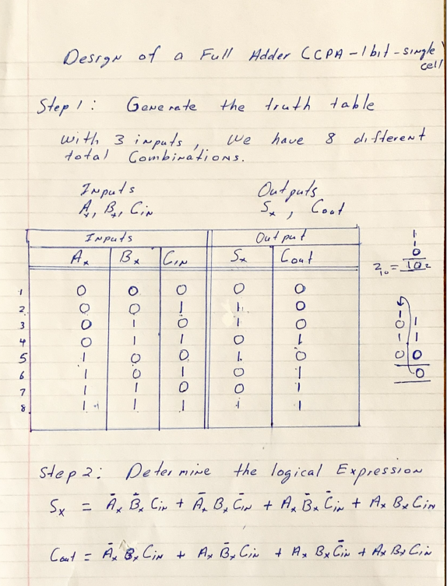

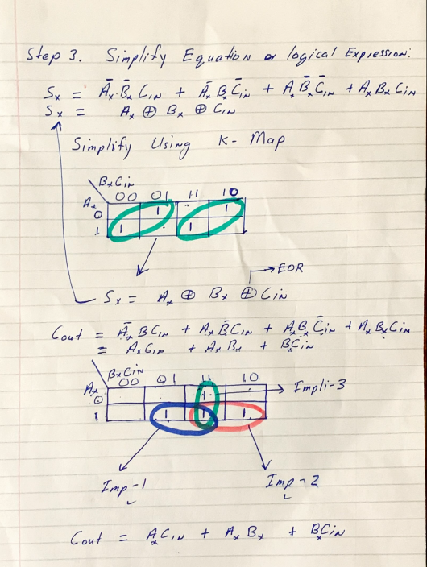

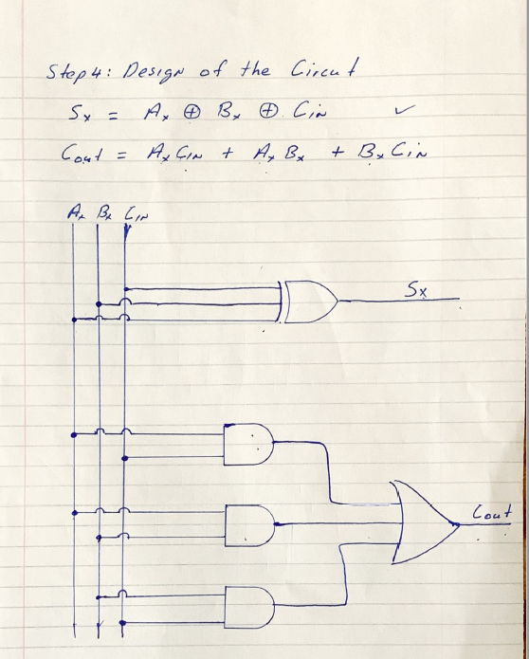

**Multiplexer**

* Selecting of data or information is a critical function in a digital systems and computers
* A Multiplexer (Mux for short) is a digital switch; Mux is a circuit used to select and route any of the several inputs to an output signal
* Mux is a combinational circuit. it has the following:
  + 2n inputs
  + n control inputs
  + one set of output
  + In summary, has the following 2n input signals, n control inputs (selector signals), and a single set of output – Output signal.
* For a multiplexer, the value of the control inputs (selector signals) determines the data input that is selected.
* Multiplexer means many into one. a simple example of a non-electronic circuit of a mux is a single pole multi-position switch. Multi-position switches are widely used in many electronics circuit, however, circuits that operate at high speed require the multiplexer to be automatically selected. A mechanical switch cannot perform this task satisfactorily. Therefore, mux is used to perform high speed switching and are constructed for digital circuits
* Example:
  + X and Y are inputs
  + S is the selector signal
  + r is the output

Design of a 1 bit, 2 to 1 mux

1. Block diagram of 1 bit, 2 to 1 mux

X

Y

Selector (S)

1 bit, 2 to 1 mux

output r

